Alumni Meet 2015
Date of meet - 10 December 2015
City – Raipur
Venue - Hotel Mayura, Raipur
No. of alumni attendees – 56 students
The Alumni Meet celebration was held for all the four passed out batches of engineering and MBA. The main aim of alumni meet was to unite maximum number of ex-students and make the alumni family bigger and stronger. The program was held in presence of Chief Guest Shri. I.P. Mishra (President, Shri Gangajali Education Society), Mr. Nishant Tripathi (Chairman, Governing Body), Dr. M. L. Dewangan, Director, Mr. Naveen Jain & Mr. Atul Chakrawarty (Board of Governors) and staff members of the institute including Dr. Seema Arora, Dr. Dhirendra Singh Kshatriya, Dr. Reena Mathur, Mr. Prashant Tripathi (PRO).

Highlights of the Alumni meet:
56 alumni attended the meet. All of these were happy to be a part of the institute and gave their valuable feedback and suggestions for the betterment of Institute. Approximately 20 faculty members were also present for the meet.
- Registration of the guest (Alumni) started around 3.00 pm.
- The Chief Guest inaugurated the Alumni Meet by lighting the lamp.
- Dr.Seema Arora welcomed the gathering with a brief history of the institute.
- Shri. Nishant Tripathi welcomed the Chief Guest Shri I P Mishra sir and presented him a Memento. He also spoke briefly about the institute’s progress and initiatives in the years gone by.
- Shri. I. P. Mishra sir addressed the gathering sharing his vision for the institute and role and involvement of Alumni.
- Various entertainment events were performed by ex- students during the event.
The meet was a great success in its prime motive of connecting and networking with alumni.
Subsequently the dignitaries, alumni and staff members had a gala dinner together. The meet also very efficiently achieved its aim of informal interaction amongst all present. .

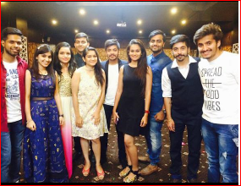
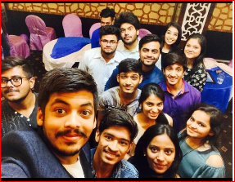
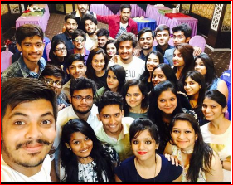
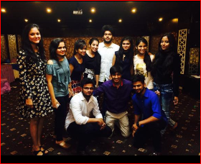
Prepared by Approved by

Nitin Jain Dr. M. L. Dewangan

